**Step 1: Asset identification, address update, dependencies, patches, and native protections at targeted Server/ Desktop Operating Systems**

**Task 1**

**First Ubuntu machine:**

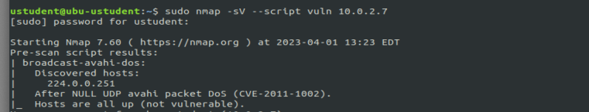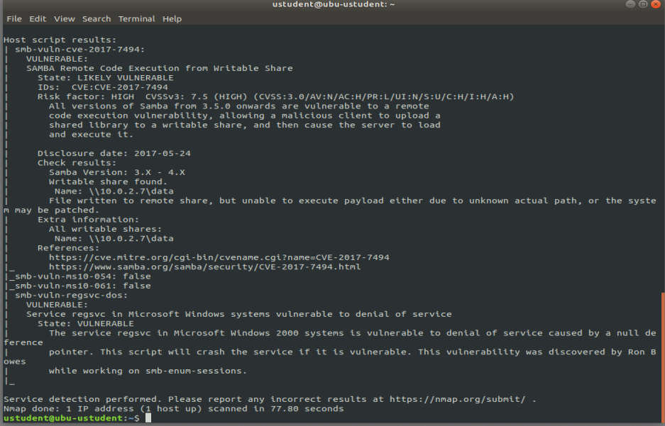

I Discovered a Vulnerability: avahi Packet DoS

**Cve -2011-1002**

Broadcast-avahi-dos

Host : 224.0.0.251

Cve classification : vulnerability is a buffer overflow vulnerability that affects the Avahi daemon, specifically in the way that the daemon handles incoming packets. It can be exploited by a remote attacker to send specially crafted packets to a vulnerable system, causing a denial of service (DoS) condition by crashing the Avahi daemon.

CVSS) score for CVE-2011-1002 is 7.8, which indicates a High severity vulnerability

Remediation : To remediate this vulnerability, it is recommended to update the affected system with the latest security patches provided by the vendor. The vulnerability was fixed in Avahi version 0.6.30, so updating to that version or a later version should resolve the issue.

Technique IDs:

* T1498.002: Network Denial of Service (DoS) - Avahi Packet Storm
* T1498.003: Network Denial of Service (DoS) - Avahi Reflection Amplification

Tools:

* Metasploit Framework: A penetration testing framework that contains modules for exploiting CVE-2011-1002.
* avahi-dos: A proof-of-concept (PoC) tool that sends specially crafted packets to trigger the DoS vulnerability.

Procedures:

* Send specially crafted packets to the Avahi daemon to trigger the vulnerability and cause the service to crash or become unresponsive.
* Use a tool like Metasploit to automate the exploitation process and launch a DoS attack against the target.
* Amplify the attack by using reflection techniques to send the packets through multiple devices on the network, increasing the volume of traffic and making it harder to trace the source of the attack.

**Smb-vuln-cve-2017-7494**

SAMBA Remote Code Execution from Writable Share

Classification : known as the SAMBA Remote Code Execution from Writable Share vulnerability, is a critical remote code execution vulnerability that affects the Samba file-sharing software. It allows a remote attacker to execute arbitrary code with root privileges by uploading a shared library to a writable share on a vulnerable system and then causing Samba to load and execute the library.

(CVSS) score for SMB-vuln-cve-2017-7494 is 8.8, which indicates a High severity vulnerability.

Remediation :

To remediate this vulnerability, it is recommended to update the Samba software to a patched version. The vulnerability was fixed in Samba versions 4.6.4, 4.5.10, and 4.4.14, so updating to one of these versions or a later version should resolve the issue

Technique IDs:

* T1190 - Exploit Public-Facing Application
* T1210 - Exploitation for Client Execution
* T1068 - Exploitation for Privilege Escalation
* T1059 - Command and Scripting Interpreter
* T1027 - Obfuscated Files or Information

Tools:

* Samba
* Nmap

Procedures:

* Exploiting the vulnerability by uploading a shared library to a writable share on a vulnerable Samba server and causing Samba to load and execute the library
* Using Metasploit modules to exploit the vulnerability and gain remote code execution
* Using Impacket to exploit the vulnerability and gain remote code execution
* Scanning for vulnerable systems using Nmap scripts
* Leveraging the vulnerability to escalate privileges and gain higher-level access to the targeted system

**Also I performed scan using openVas on ubuntu host** 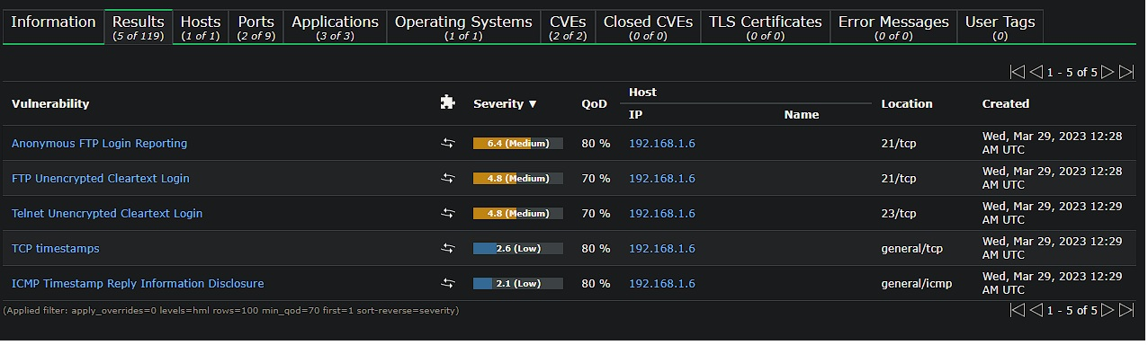

|  |
| --- |
| Medium (CVSS: 4.8) NVT: Telnet Unencrypted Cleartext Login |
| Summary The remote host is running a Telnet service that allows cleartext logins over unencrypted connections. |
| Vulnerability Detection Result Vulnerability was detected according to the Vulnerability Detection Method. |
| Impact An attacker can uncover login names and passwords by sni‑ng tra‑c to the Telnet service. |
| Solution: Solution type: Mitigation Replace Telnet with a protocol like SSH which supports encrypted connections. |
| Vulnerability Detection Method Details: Telnet Unencrypted Cleartext Login OID:1.3.6.1.4.1.25623.1.0.108522 Version used: 2020-08-24T08:40:10Z |

|  |
| --- |
| Summary Reports if the remote FTP Server allows anonymous logins. |
| Vulnerability Detection Result It was possible to login to the remote FTP service with the following anonymous *,!*account(s): anonymous:anonymous@example.com ftp:anonymous@example.com |
| Impact Based on the les accessible via this anonymous FTP login and the permissions of this account an attacker might be able to: - gain access to sensitive les - upload or delete les. |
| Solution: Solution type: Mitigation |
| If you do not want to share les, you should disable anonymous logins. |
| Vulnerability Insight A host that provides an FTP service may additionally provide Anonymous FTP access as well. Under this arrangement, users do not strictly need an account on the host. Instead the user typically enters 'anonymous' or 'ftp' when prompted for username. Although users are commonly asked to send their email address as their password, little to no verication is actually performed on the supplied data. Remark: NIST don't see 'conguration issues' as software aws so the referenced CVE has a severity of 0.0. The severity of this VT has been raised by Greenbone to still report a conguration issue on the target. |
| Vulnerability Detection Method Details: Anonymous FTP Login Reporting OID:1.3.6.1.4.1.25623.1.0.900600 Version used: 2021-10-20T09:03:29Z |
| References cve: CVE-1999-0497 |

|  |
| --- |
| Summary The remote host is running a FTP service that allows cleartext logins over unencrypted connec tions. |
| Vulnerability Detection Result The remote FTP service accepts logins without a previous sent 'AUTH TLS' command *,!*. Response(s): Anonymous sessions: 331 Please specify the password. Non-anonymous sessions: 331 Please specify the password. |
| Impact An attacker can uncover login names and passwords by sni‑ng tra‑c to the FTP service. |
| Solution: Solution type: Mitigation Enable FTPS or enforce the connection via the 'AUTH TLS' command. Please see the manual of the FTP service for more information. |
| Vulnerability Detection Method Tries to login to a non FTPS enabled FTP service without sending a 'AUTH TLS' command rst and checks if the service is accepting the login without enforcing the use of the 'AUTH TLS' command. |

|  |
| --- |
|  |
| Details: FTP Unencrypted Cleartext Login OID:1.3.6.1.4.1.25623.1.0.108528 Version used: 2020-08-24T08:40:10Z |

|  |
| --- |
| Low (CVSS: 2.1) NVT: ICMP Timestamp Reply Information Disclosure |
| Summary The remote host responded to an ICMP timestamp request. |
| Vulnerability Detection Result Vulnerability was detected according to the Vulnerability Detection Method. |
| Solution: Solution type: Mitigation Various mitigations are possible: - Disable the support for ICMP timestamp on the remote host completely - Protect the remote host by a rewall, and block ICMP packets passing through the rewall in either direction (either completely or only for untrusted networks) |
| Vulnerability Insight The Timestamp Reply is an ICMP message which replies to a Timestamp message. It consists of the originating timestamp sent by the sender of the Timestamp as well as a receive timestamp and a transmit timestamp. This information could theoretically be used to exploit weak time-based random number generators in other services. |
| Vulnerability Detection Method Details: ICMP Timestamp Reply Information Disclosure OID:1.3.6.1.4.1.25623.1.0.103190 Version used: 2022-11-18T10:11:40Z |
| References cve: CVE-1999-0524 url: http://www.ietf.org/rfc/rfc0792.txt cert-bund: CB-K15/1514 cert-bund: CB-K14/0632 dfn-cert: DFN-CERT-2014-0658 |

|  |
| --- |
| Low (CVSS: 2.6) NVT: TCP timestamps |
| Summary The remote host implements TCP timestamps and therefore allows to compute the uptime. |
| Vulnerability Detection Result It was detected that the host implements RFC1323/RFC7323. The following timestamps were retrieved with a delay of 1 seconds in-between: Packet 1: 3503625356 Packet 2: 3503626424 |
| Impact A side eect of this feature is that the uptime of the remote host can sometimes be computed. |
| Solution: Solution type: Mitigation To disable TCP timestamps on linux add the line 'net.ipv4.tcp_timestamps = 0' to /etc/sysctl.conf. Execute 'sysctl -p' to apply the settings at runtime. To disable TCP timestamps on Windows execute 'netsh int tcp set global timestamps=disabled' Starting with Windows Server 2008 and Vista, the timestamp can not be completely disabled. The default behavior of the TCP/IP stack on this Systems is to not use the Timestamp options when initiating TCP connections, but use them if the TCP peer that is initiating communication includes them in their synchronize (SYN) segment. See the references for more information. |
| Aected Software/OS TCP implementations that implement RFC1323/RFC7323. |
| Vulnerability Insight The remote host implements TCP timestamps, as dened by RFC1323/RFC7323. |
| Vulnerability Detection Method Special IP packets are forged and sent with a little delay in between to the target IP. The responses are searched for a timestamps. If found, the timestamps are reported. Details: TCP timestamps OID:1.3.6.1.4.1.25623.1.0.80091 Version used: 2020-08-24T08:40:10Z |
| References url: http://www.ietf.org/rfc/rfc1323.txt url: http://www.ietf.org/rfc/rfc7323.txt url: https://web.archive.org/web/20151213072445/http://www.microsoft.com/en-us/d *,!*ownload/details.aspx?id=9152 |

**In Windows Vuln Scan**

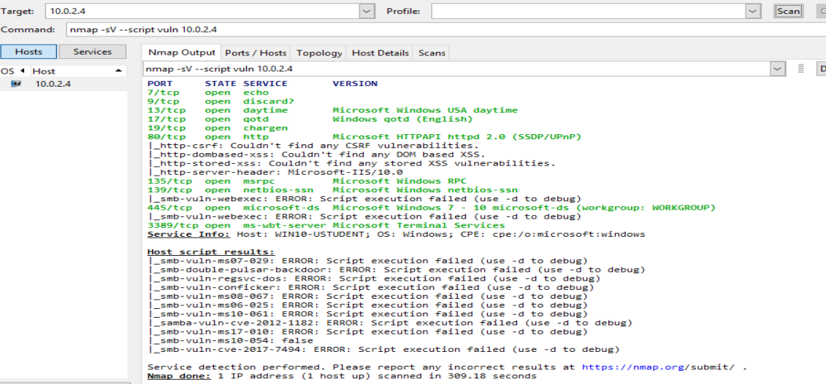

**CVE-2012-1182**

Classification : vulnerability is a buffer overflow vulnerability in the Samba software that allows a remote attacker to execute arbitrary code on a vulnerable system. This vulnerability is triggered by sending a specially crafted packet to a vulnerable system, which can lead to a stack-based buffer overflow and subsequent execution of arbitrary code.

(CVSS) score for CVE-2012-1182 is 5.0, which indicates a Moderate severity vulnerability.

Remediation : To remediate this vulnerability, it is recommended to update the Samba software to a patched version. The vulnerability was fixed in Samba versions 3.6.5, 3.5.15, and 3.4.15, so updating to one of these versions or a later version should resolve the issue.

Technique IDs:

* T1190 - Exploit Public-Facing Application
* T1210 - Exploitation for Client Execution
* T1068 - Exploitation for Privilege Escalation
* T1059 - Command and Scripting Interpreter

Tools:

* Metasploit Framework
* Samba
* Nmap

Procedures:

* Exploiting the buffer overflow vulnerability by sending a specially crafted packet to a vulnerable Samba server
* Using Metasploit modules to exploit the vulnerability and gain remote code execution
* Scanning for vulnerable systems using Nmap scripts
* Leveraging the vulnerability to escalate privileges and gain higher-level access to the targeted system.

**CVE-2017-7494**

Classification : The SMB-vuln-cve-2017-7494 vulnerability, also known as the SAMBA Remote Code Execution from Writable Share vulnerability, is a critical remote code execution vulnerability that affects the Samba file-sharing software. It allows a remote attacker to execute arbitrary code with root privileges by uploading a shared library to a writable share on a vulnerable system and then causing Samba to load and execute the library.

(CVSS) score for CVE-2017-7494 is 8.8, which indicates a High severity vulnerability.

Remediation: To remediate this vulnerability, it is recommended to update the Samba software to a patched version. The vulnerability was fixed in Samba versions 4.6.4, 4.5.10, and 4.4.14, so updating to one of these versions or a later version should resolve the issue.

CVE-2017-7494:

Technique IDs:

* T1059.001 - Command and Scripting Interpreter: PowerShell
* T1027 - Obfuscated Files or Information
* T1024 - Custom Cryptographic Protocol
* T1210 - Exploitation for Client Execution
* T1068 - Exploitation for Privilege Escalation
* T1055 - Process Injection

Tools:

* Metasploit Framework
* Impacket
* Nmap
* Samba

Procedures:

* Exploiting the vulnerability using a specially crafted packet to execute arbitrary code on a vulnerable system
* Uploading a shared library to a writable share on a vulnerable system and causing Samba to load and execute the library
* Using Metasploit modules to exploit the vulnerability and gain remote code execution
* Using Impacket to exploit the vulnerability and gain remote code execution
* Using Nmap scripts to detect vulnerable systems

**Also I performed openVas on windows machine**

|  |
| --- |
| High (CVSS: 10.0)  NVT: Check for discard Service |
| Summary The remote host is running a 'discard' service. This service typically sets up a listening socket and will ignore all the data which it receives. This service is unused these days, so it is advised that you disable it. |
| Vulnerability Detection Result The discard service was detected on the target host. |
| Solution: Solution type: Mitigation - Under Unix systems, comment out the 'discard' line in /etc/inetd.conf and restart the inetd process - Under Windows systems, set the following registry key to 0: HKLM\System\CurrentControlSet\Services\SimpTCP\Parameters\EnableTcpDiscard Then launch cmd.exe and type: net stop simptcp net start simptcp To restart the service. |
| Vulnerability Detection Method Checks if a vulnerable version is present on the target host. Details: Check for discard Service OID:1.3.6.1.4.1.25623.1.0.11367 Version used: 2020-10-01T11:33:30Z |
|  |

|  |
| --- |
| High (CVSS: 10.0) NVT: SMB Brute Force Logins With Default Credentials |
| Summary A number of known default credentials are tried for the login via the SMB protocol. |
| Vulnerability Detection Result It was possible to login with the following credentials via the SMB protocol to *,!*the 'IPC$' share. <User>:<Password> operator:1234 |
| Solution: Solution type: Mitigation Change the password as soon as possible. |
| Vulnerability Detection Method Tries to login with a number of known default credentials via the SMB protocol. Details: SMB Brute Force Logins With Default Credentials OID:1.3.6.1.4.1.25623.1.0.804449 Version used: 2022-04-11T14:03:55Z |
| References cve: CVE-1999-0503 cve: CVE-1999-0504 cve: CVE-1999-0505 cve: CVE-1999-0506 |

|  |
| --- |
| Medium (CVSS: 5.0) NVT: DCE/RPC and MSRPC Services Enumeration Reporting |
| Summary Distributed Computing Environment / Remote Procedure Calls (DCE/RPC) or MSRPC ser vices running on the remote host can be enumerated by connecting on port 135 and doing the appropriate queries. |
| Vulnerability Detection Result Here is the list of DCE/RPC or MSRPC services running on this host via the TCP p *,!*rotocol: Port: 1536/tcp |
| |  | | --- | | Impact An attacker may use this fact to gain more knowledge about the remote host. | | Solution: Solution type: Mitigation Filter incoming tra‑c to this ports. | | Vulnerability Detection Method Details: DCE/RPC and MSRPC Services Enumeration Reporting OID:1.3.6.1.4.1.25623.1.0.10736 Version used: 2022-06-03T10:17:07Z | |

|  |
| --- |
| Medium (CVSS: 4.3) NVT: SSL/TLS: Deprecated TLSv1.0 and TLSv1.1 Protocol Detection |
| Summary It was possible to detect the usage of the deprecated TLSv1.0 and/or TLSv1.1 protocol on this system. |
| Vulnerability Detection Result In addition to TLSv1.2+ the service is also providing the deprecated TLSv1.0 and *,!* TLSv1.1 protocols and supports one or more ciphers. Those supported ciphers c *,!*an be found in the 'SSL/TLS: Report Supported Cipher Suites' (OID: 1.3.6.1.4.1 *,!*.25623.1.0.802067) VT. |
| Impact An attacker might be able to use the known cryptographic aws to eavesdrop the connection between clients and the service to get access to sensitive data transferred within the secured connection. |
| |  | | --- | | Solution: Solution type: Mitigation It is recommended to disable the deprecated TLSv1.0 and/or TLSv1.1 protocols in favor of the TLSv1.2+ protocols. Please see the references for more information. | | Aected Software/OS All services providing an encrypted communication using the TLSv1.0 and/or TLSv1.1 protocols. | | Vulnerability Insight The TLSv1.0 and TLSv1.1 protocols contain known cryptographic aws like: - CVE-2011-3389: Browser Exploit Against SSL/TLS (BEAST) - CVE-2015-0204: Factoring Attack on RSA-EXPORT Keys Padding Oracle On Downgraded Legacy Encryption (FREAK) | | Vulnerability Detection Method Check the used TLS protocols of the services provided by this system. Details: SSL/TLS: Deprecated TLSv1.0 and TLSv1.1 Protocol Detection OID:1.3.6.1.4.1.25623.1.0.117274 Version used: 2021-07-19T08:11:48Z | | References cve: CVE-2015-0204 cve: CVE-2011-3389 | |

|  |
| --- |
| Medium (CVSS: 5.0) NVT: Check for Quote of the Day (qotd) Service (TCP) |
| Summary The Quote of the Day (qotd) service is running on this host. |
| Vulnerability Detection Result Vulnerability was detected according to the Vulnerability Detection Method. |
| Impact An easy attack is 'pingpong' which IP spoofs a packet between two machines running qotd. This will cause them to spew characters at each other, slowing the machines down and saturating the network. |
| Solution: Solution type: Mitigation - Under Unix systems, comment out the 'qotd' line in /etc/inetd.conf and restart the inetd process - Under Windows systems, set the following registry keys to 0 : HKLM\System\CurrentControlSet\Services\SimpTCP\Parameters\EnableTcpQotd HKLM\System\CurrentControlSet\Services\SimpTCP\Parameters\EnableUdpQotd Then launch cmd.exe and type : net stop simptcp net start simptcp To restart the service. |
| Vulnerability Insight A server listens for TCP connections on TCP port 17. Once a connection is established a short message is sent out the connection (and any data received is thrown away). The service closes the connection after sending the quote. Remark: NIST don't see 'conguration issues' as software aws so the referenced CVE has a severity of 0.0. The severity of this VT has been raised by Greenbone to still report a conguration issue on the target. |
| Vulnerability Detection Method Details: Check for Quote of the Day (qotd) Service (TCP) OID:1.3.6.1.4.1.25623.1.0.10198 Version used: 2021-10-20T09:03:29Z |
| References cve: CVE-1999-0103 |

|  |
| --- |
| Medium (CVSS: 5.0) NVT: echo Service Reporting (TCP + UDP) |
| Summary An echo Service is running at this Host via TCP and/or UDP. |
| Vulnerability Detection Result Vulnerability was detected according to the Vulnerability Detection Method. |
| Solution: Solution type: Mitigation Disable the echo Service. |
| Vulnerability Insight The echo service is an Internet protocol dened in RFC 862. It was originally proposed for testing and measurement of round-trip times in IP networks. While still available on most UNIX-like operating systems, testing and measurement is now performed with the Internet Control Message Protocol (ICMP), using the applications ping and traceroute. Remark: NIST don't see 'conguration issues' as software aws so the referenced CVE has a severity of 0.0. The severity of this VT has been raised by Greenbone to still report a conguration issue on the target. |
| Vulnerability Detection Method Details: echo Service Reporting (TCP + UDP) OID:1.3.6.1.4.1.25623.1.0.100075 Version used: 2021-10-20T09:03:29Z |
| References cve: CVE-1999-0635 |
|  |

|  |
| --- |
| Low (CVSS: 2.1) NVT: ICMP Timestamp Reply Information Disclosure |
| Summary The remote host responded to an ICMP timestamp request. |
| Vulnerability Detection Result Vulnerability was detected according to the Vulnerability Detection Method. |
| Solution: Solution type: Mitigation Various mitigations are possible: - Disable the support for ICMP timestamp on the remote host completely - Protect the remote host by a rewall, and block ICMP packets passing through the rewall in either direction (either completely or only for untrusted networks) |
| Vulnerability Insight The Timestamp Reply is an ICMP message which replies to a Timestamp message. It consists of the originating timestamp sent by the sender of the Timestamp as well as a receive timestamp and a transmit timestamp. This information could theoretically be used to exploit weak time-based random number generators in other services. |
| Vulnerability Detection Method Details: ICMP Timestamp Reply Information Disclosure OID:1.3.6.1.4.1.25623.1.0.103190 Version used: 2022-11-18T10:11:40Z |
| References cve: CVE-1999-0524 url: http://www.ietf.org/rfc/rfc0792.txt cert-bund: CB-K15/1514 cert-bund: CB-K14/0632 dfn-cert: DFN-CERT-2014-0658 |

**TASK 2**

**In Windows** 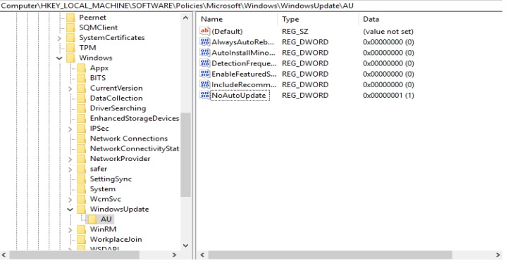

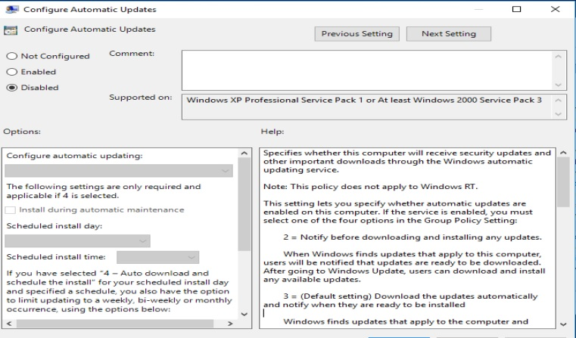

No, Software Updates weren’t configured correctly.

To remediate it 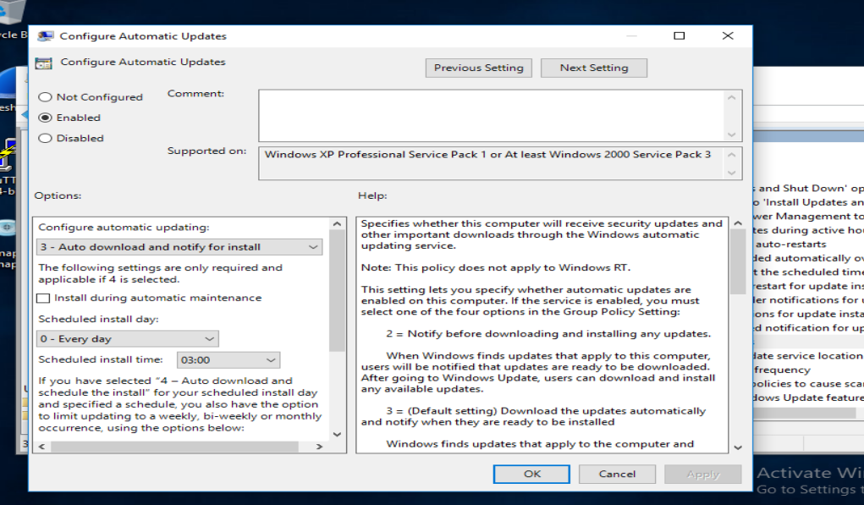

My Assessment

I would consider this a serious security risk that needs to be addressed as soon as possible.

it represents a significant security risk that requires immediate attention and remediation to minimize the risk of a security incident or breach.

**In Ubuntu :**

The Package manager Repositories aren’t configured correctly 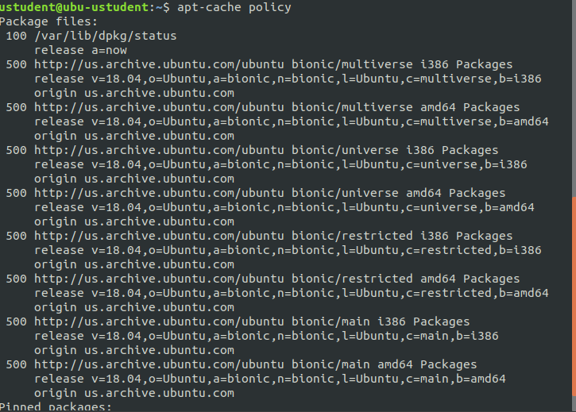to remediate it 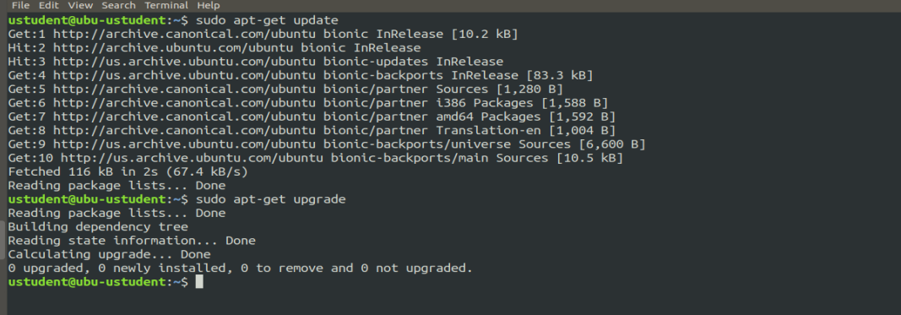

### **Task 3- Native Protections and Software Inventory**

**In windows :**

Ensure 'Enable Structured Exception Handling Overwrite Protection’ 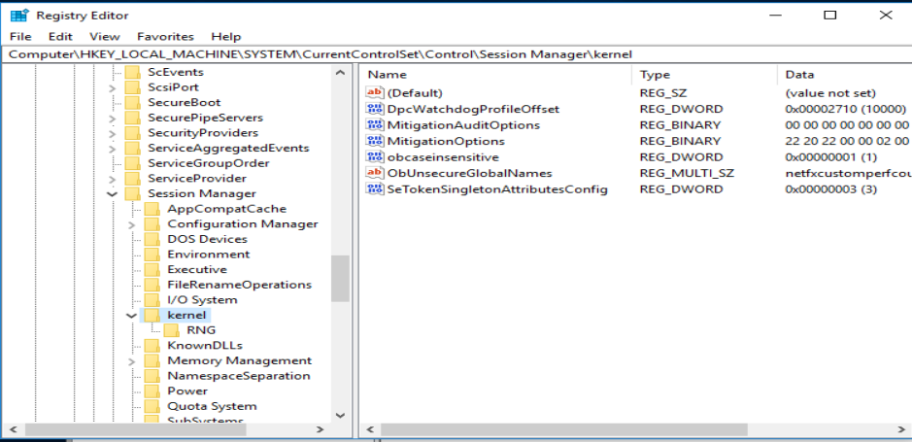

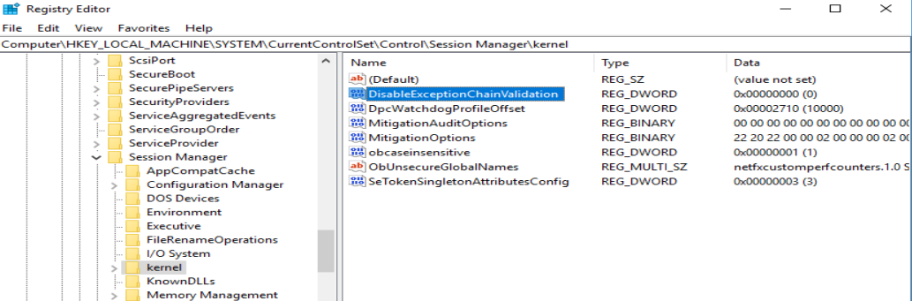

No, The System Isn’t Compliant

YES, VNC Viewer is installed 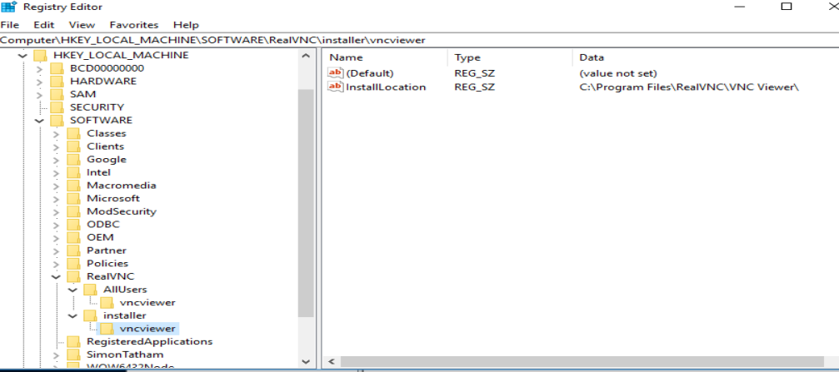

In UBUNTU :

1.6.1 Ensure XD/NX support is enabled

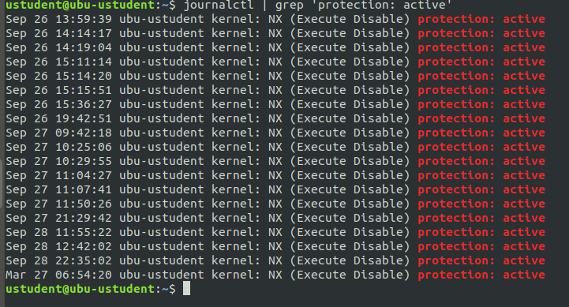

1.6.2 Ensure address space layout randomization (ASLR) is enabled

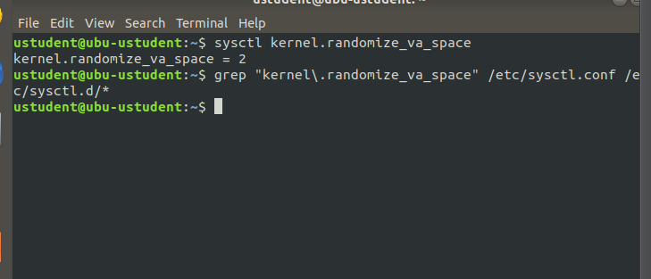

According to these checks the native protections is applied   
We could list the package installed on ubuntu machine from this command

“dpkg –get-selections”

--

tightVNC is Installed on Ubuntu machine 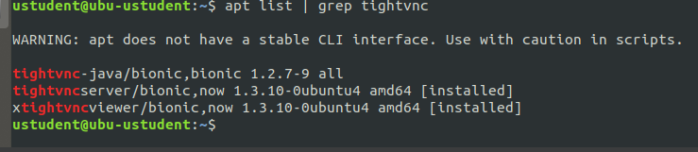

While these applications can be useful for remote administration, they can also pose security risks if not properly configured.

In general, any software that enables remote access to a computer can potentially create a security vulnerability. VNC and TightVNC are no exception. If attackers are able to gain access to a computer running VNC or TightVNC, they could potentially access sensitive data, install malware, or take control of the computer.

----------------------------------------------------------------------------

**Task 4**

I Performed Network Asset Inventory From Ubuntu on the whole network :“sudo nmap -sV 10.0.2.0/24”

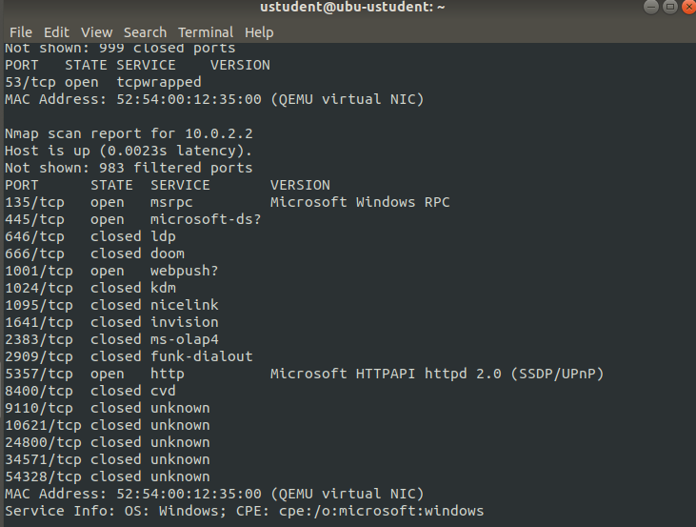

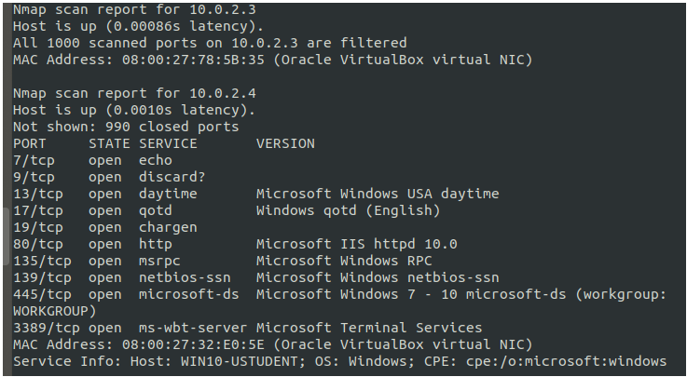

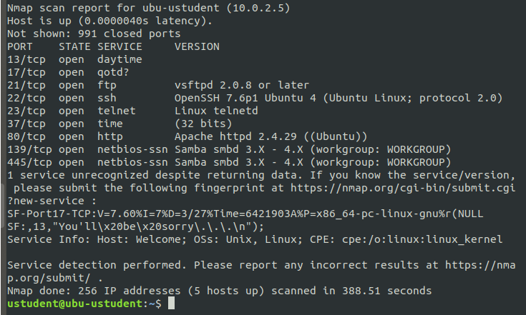

My Recommendation to Mitigate any Potential issues :

1. Use automated tools: Use automated network scanning tools to identify and document all the assets on the network. This can help reduce the likelihood of missing critical assets and can save time and effort.
2. Categorize assets: Categorize assets based on their criticality, location, and sensitivity. This can help prioritize security measures and make it easier to identify and manage potential risks.
3. Update asset inventory regularly: Update the asset inventory on a regular basis to ensure that it remains accurate and up-to-date. This can help identify new assets that may have been added to the network or identify assets that are no longer in use.
4. Perform vulnerability scanning: Perform vulnerability scanning on the identified assets to identify potential security risks. This can help identify vulnerabilities that can be used to exploit the assets.
5. Conduct risk assessment: Conduct a risk assessment on the identified assets to identify the potential impact and likelihood of various security risks. This can help prioritize security measures and identify areas that need additional attention.
6. Implement access controls: Implement access controls to limit access to critical assets only to authorized users. This can help prevent unauthorized access and reduce the likelihood of a successful attack.
7. Secure remote access: Ensure that remote access to assets is secure by using secure protocols like VPNs, implementing two-factor authentication, and limiting remote access to only authorized users.

**Step 2: Assess Access Management at Targeted Assets**

**Task 1 :**

In Ubuntu :

There’s a NO VLANs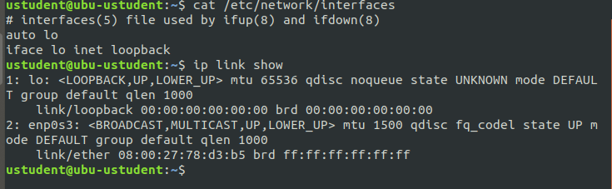

Also there’s no Policies it’s the default policies 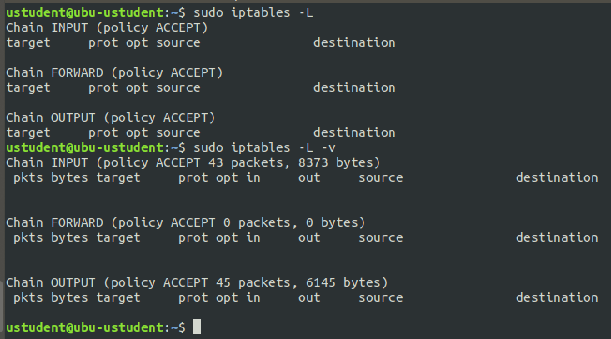

And there’s no Anonymous access 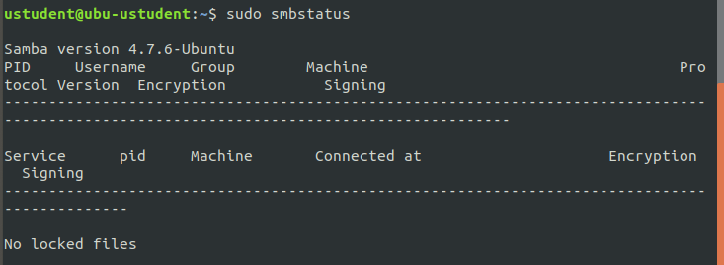

My Assessment : This may pose a security risk as it can allow unauthorized access or attacks on the system.  
To improve the settings, it is recommended to implement VLANs and IP security policies. VLANs can help segregate network traffic and limit access to specific resources

**In Windows Machine**

Yes There’s VLAN on Windows 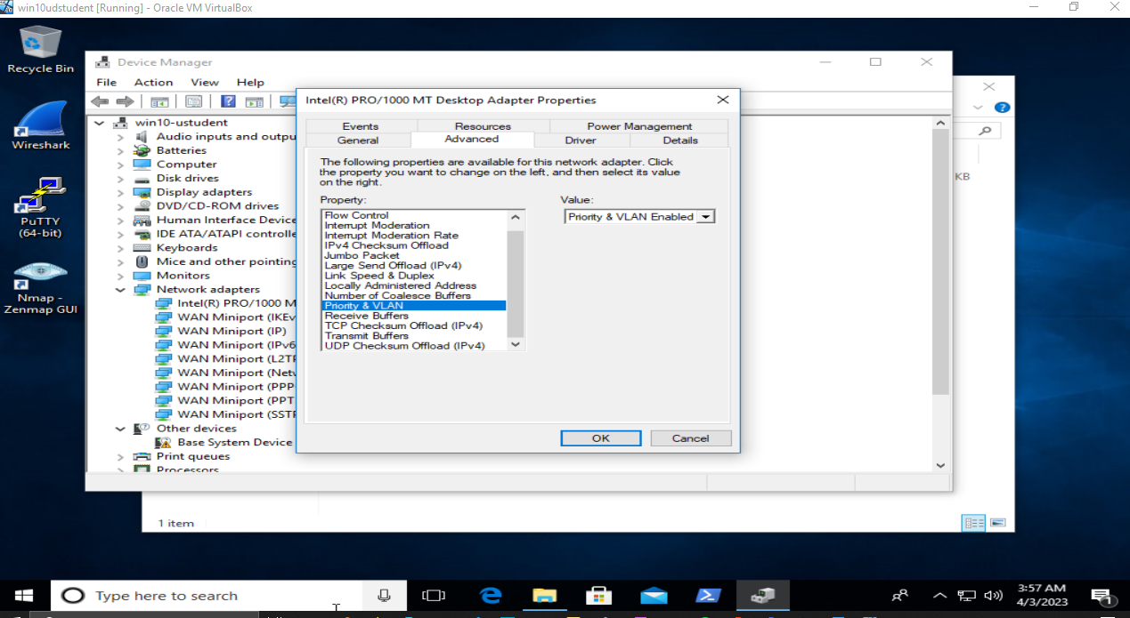

There’s Policy but not applied 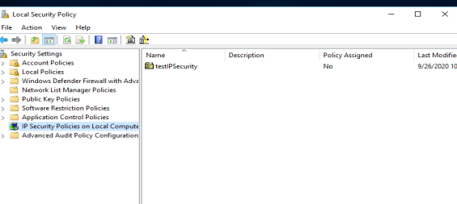

Yes, Anonymous access granted to any shares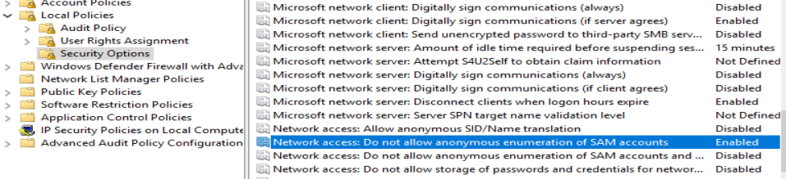

My Assessment and recommendation:

* 1. recommended to use VLANs to segment network traffic and improve security. VLANs help to separate different types of network traffic and reduce the risk of unauthorized access or data leakage.
  2. recommended to implement IPsec policies to encrypt network traffic and protect against network-based attacks. IPsec provides a way to secure communications between hosts and can be used to enforce security policies such as authentication, integrity, and confidentiality.
  3. Anonymous access to shares can pose a security risk as it allows anyone to access shared resources without authentication. It is recommended to disable anonymous access and enforce authentication to improve security.

**TASK 2**

**In Windows:**

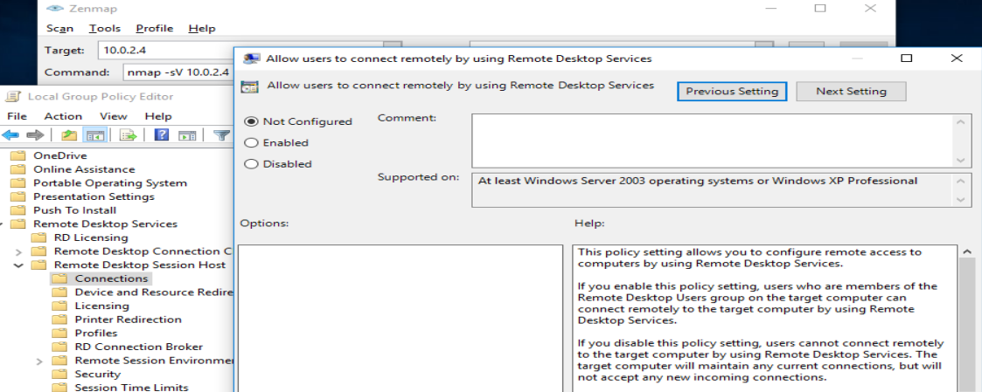

The Remote Services and protocols policy is not configured.

The remote Service protocols are running on the windows Machine:

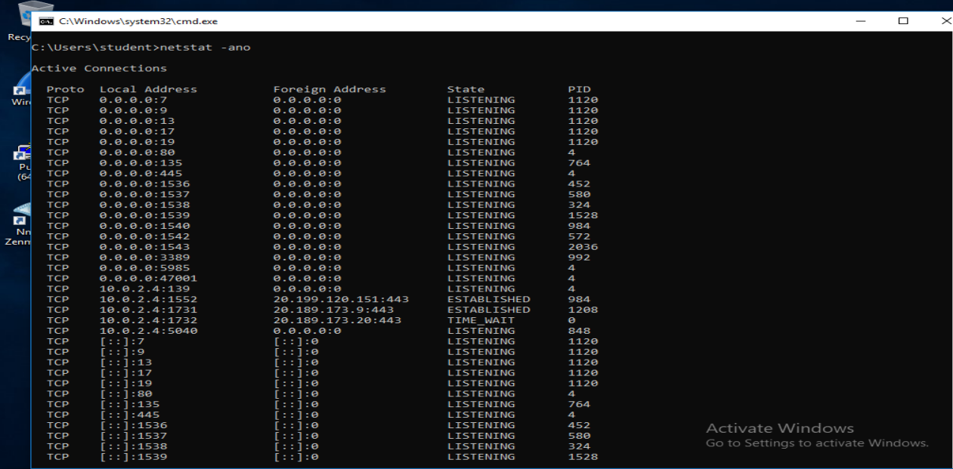

HTTP, MSRPC, NETBIOS-SSN, MICROSOFT-DS

Also ipv6 is running on windows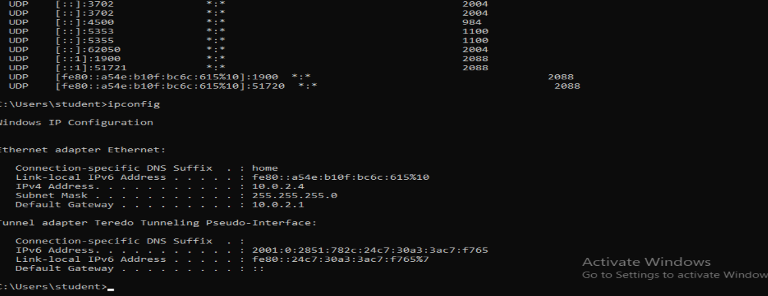

1. Disable unnecessary services: Echo, Discard, Daytime, Quote of the Day (QOTD), and Character Generator (CHARGEN) services are rarely used and can be disabled. Disabling these services will reduce the attack surface of your system.
2. Disable insecure protocols: The NetBIOS-SSN protocol (port 138/tcp) is often used by attackers to conduct reconnaissance and launch attacks. You should consider disabling this protocol if it is not required in your environment.
3. Harden the HTTP service: If the HTTP service (port 80/tcp) is required, it should be hardened by applying security patches, using secure configurations, and implementing HTTPS encryption.

**In Ubuntu:**

remote access service Policy not configured on ubuntu machine because the uwf not active

To list the remote service protocols, we could use “netstat -tuplan”

The Remote Service Protocols are Running on Ubuntu Machine:

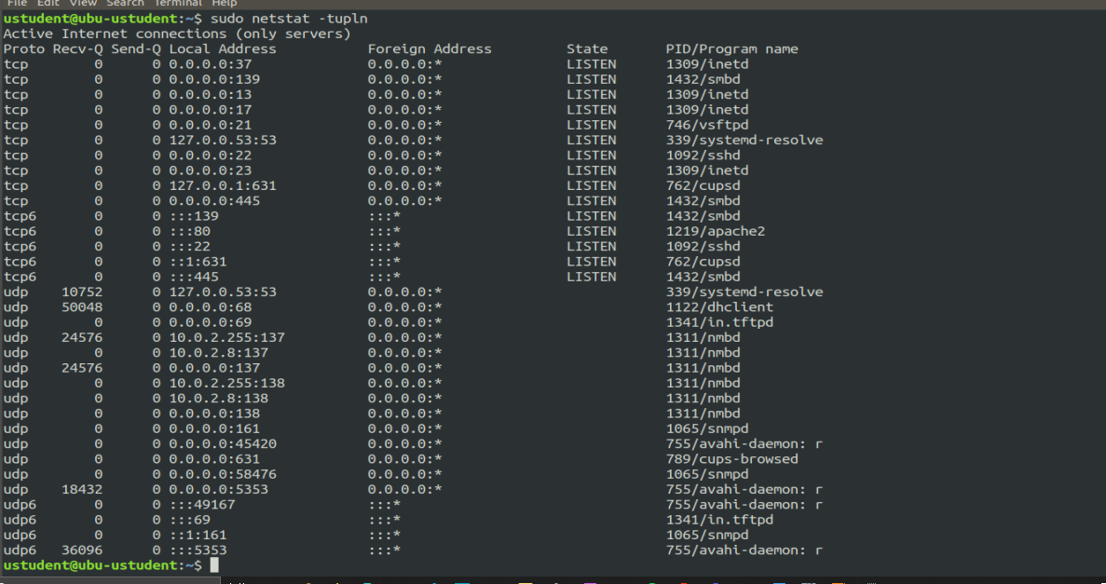  
also ipv6 is running on ubuntu 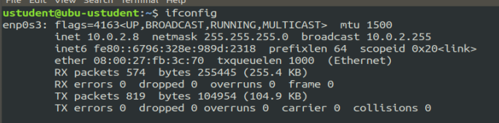

My Recommendation:

1. Only allowing necessary remote access services and protocols, and disabling or blocking all others.
2. Configuring the remote access services and protocols to use secure authentication and encryption methods, such as SSH with key-based authentication and encryption.
3. Monitoring and logging all remote access activity, and regularly reviewing the logs for any signs of unauthorized access or other security incidents.

**TASK 3**

On Ubuntu Machine:

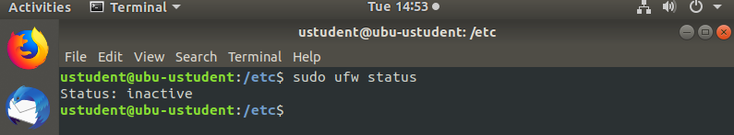

The firewall: inactive

On Windows Machine:

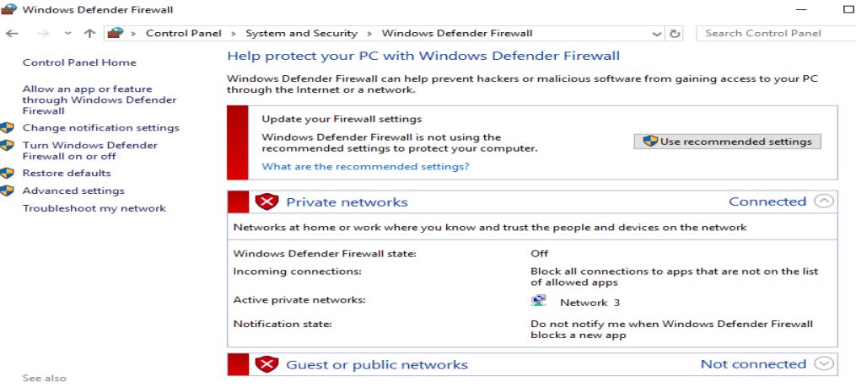Also not Configured

this means that both machines are currently not protected by a firewall. This could potentially leave them vulnerable to unauthorized access and attacks from malicious actors.

The ports that I suggest being open.

* Port 80 (HTTP): This is the standard port used for web traffic, and is required if you want to host a website on your server.
* Port 443 (HTTPS): This port is used for secure web traffic (encrypted with SSL/TLS) and is required if you want to host a website with HTTPS enabled.
* Port 22 (SSH): This port is used for secure shell (SSH) access, and is required if you want to remotely access your server or computer via SSH.
* Port 53 (DNS): This port is used for DNS traffic, and is required if you want to run a DNS server.

### **Task 4**

**On Windows**

-The users with highest privileges  
administrator, student

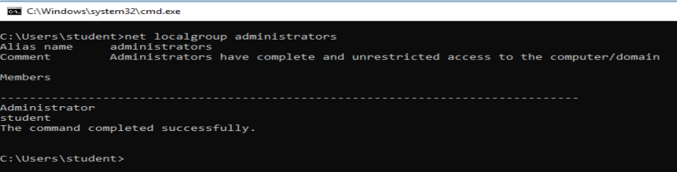

-the PII folders seem have the correct permissions and ownership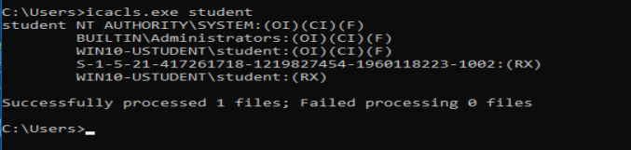

-The default settings seem correct and there’s not excessive permissions 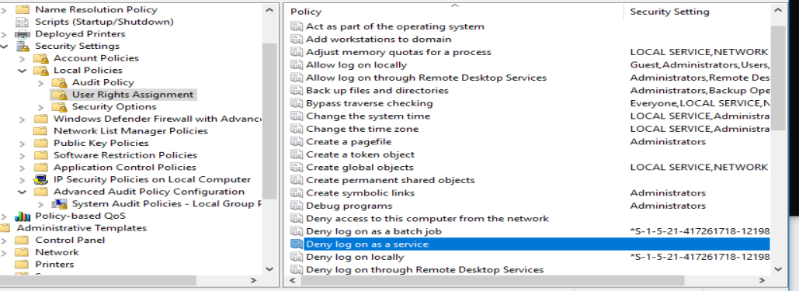

-The “data” Folder has no permissions everyone could access the folder. 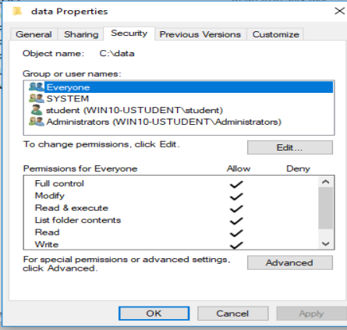

-Guest Account Are enables, but Not have the administrator privilege, the guest user allowed only to log in locally

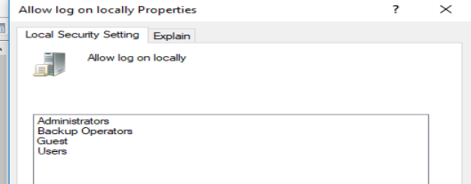

**ON UBUNTU:**

-The user who has the highest privileges : is the root 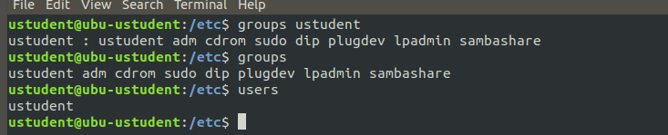

Also the members in the root group has the privilege so ustudent has high privilege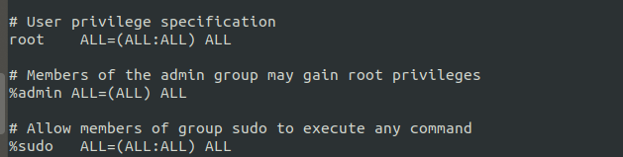

-the PII Folders don’t have the correct permissions ownership it should be 700 or 500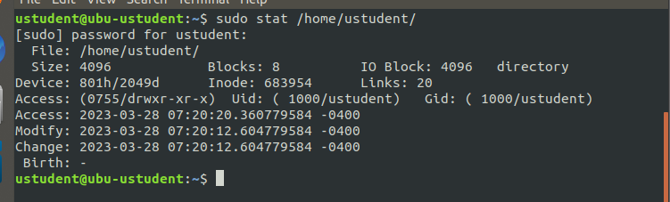

-The “data” Shared folder has no permissions, its accessible by everyone 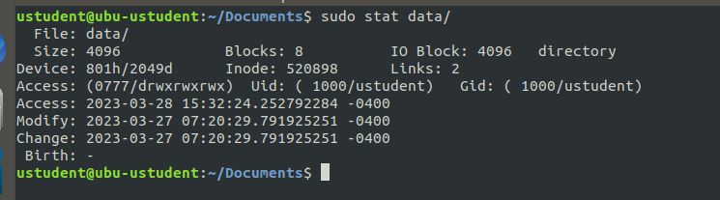

-There’s Guest user on , but aren’t allowed to use ‘sudo’ commands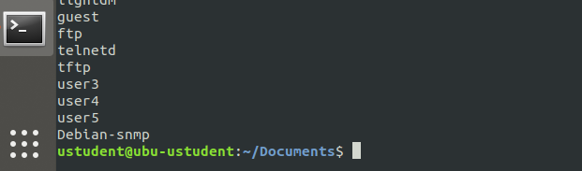

Based on the findings:

1. Remove the guest account or limit its privileges: Since the guest account has no administrative privileges, it can be used by an attacker to gain access to your system. To prevent this, you can either remove the guest account entirely or limit its privileges by configuring Group Policy settings.
2. Review the permissions of the "DATA" folder: If the "DATA" folder is shared with no permissions, it means that anyone can access it without any restrictions. This could potentially lead to a data breach. To secure this folder, you should review the permissions and ensure that only authorized users have access to it.
3. Limit the number of accounts with administrative privileges: The more accounts that have administrative privileges, the more vulnerable your system is to attacks. You should limit the number of accounts with administrative privileges to only those who require them.

Step 3: Log Monitoring Setup for Detection at Targeted Assets

**Task 1**

The attack type: Bruteforce

The source IP of attack is: 10.0.2.7

The Targeted protocol: telnet

The password used successfully: 1234

The user was compromised: ustudent

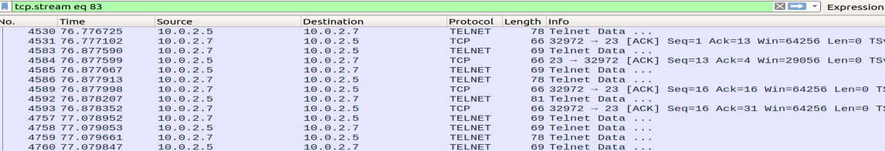

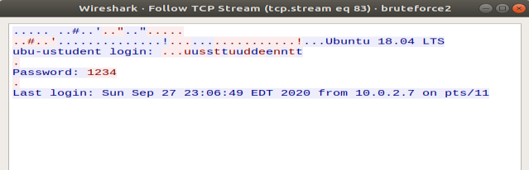

There was a bruteforce attack that targeted the telnet protocol

From ipaddress 10.0.2.7

And that attack able to compromised ustudent user on the machine

**Task 2**

The source of the initial attack: 10.0.2.7

Yes, the attacker tried to access the Machine from Compromised device

The service: NETBIOS ,SMB2 Protocol on port: 445

Yes, the attacker able to access a sensitive file at the machine using Mitre ATT&ACK Technique - T1570

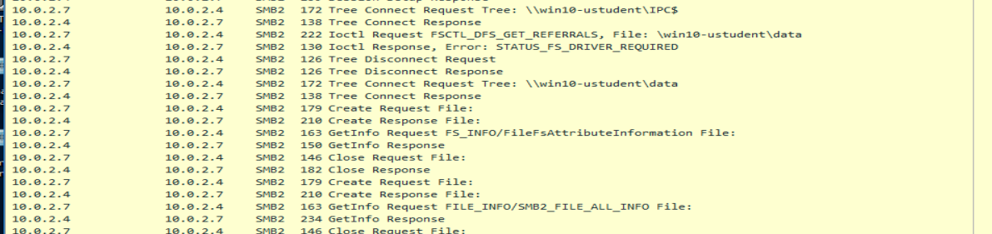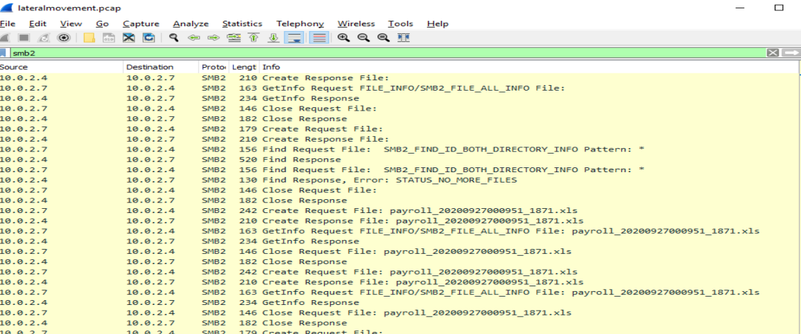

Based on the analysis of the pcap file, it appears that the attacker targeted the SMB2 protocol to gain access to the victim's machine. The attacker attempted to establish a session using the user account "./student" and was successful in gaining access to the victim's machine.

The attacker then attempted to access the user's data directory, but was denied access. The attacker then turned their attention to the workgroup of the user and was able to gain access to shared data.

### **Task 3**

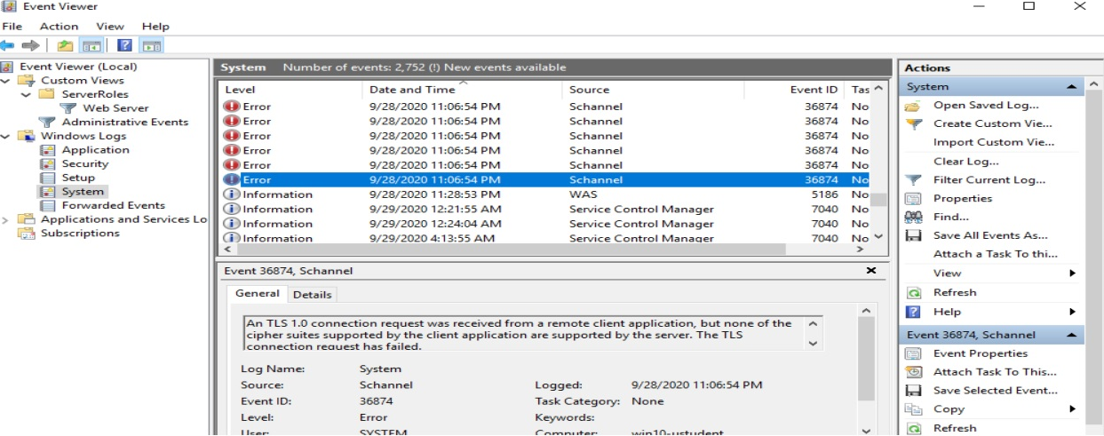

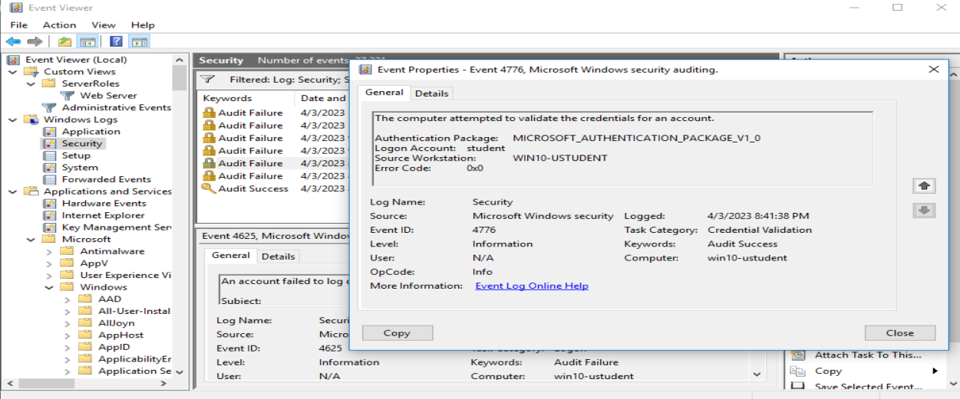

Also there’s authentication failure with smb server  
  
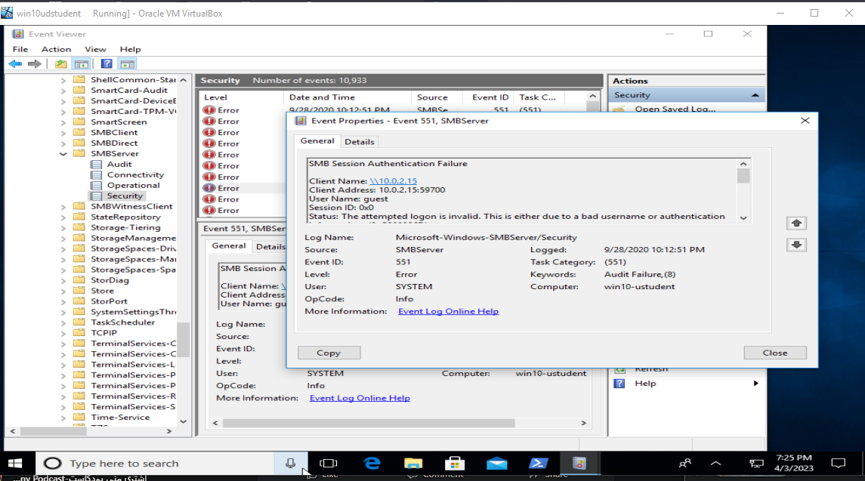

There is an issue with windows share.

On ubuntu:

I used “aureport” to filter all logs

The Name of The Attacker’s Account is: UNKNOWN

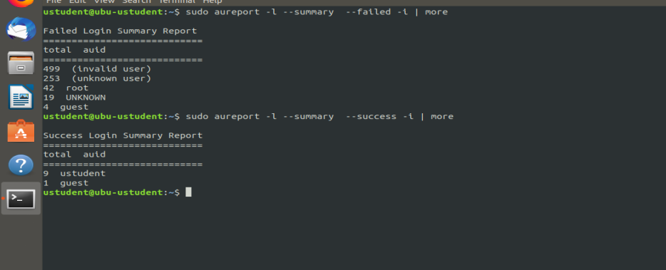

My assessment   
Yes, these events are definitely enough to start an investigation, as they indicate a potential security breach or unauthorized access to the systems.

**Task 4**

In Ubuntu: Reviewing the contents of rsyslog.conf and rsyslog.d/*.conf files to ensure  
appropriate logging is set In addition, run the following command and verify that the log  
files are logging information:

# ls -l /var/log/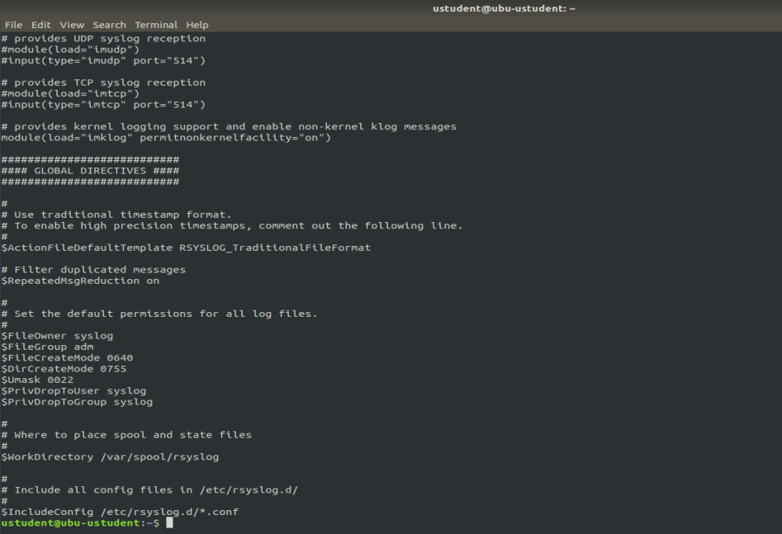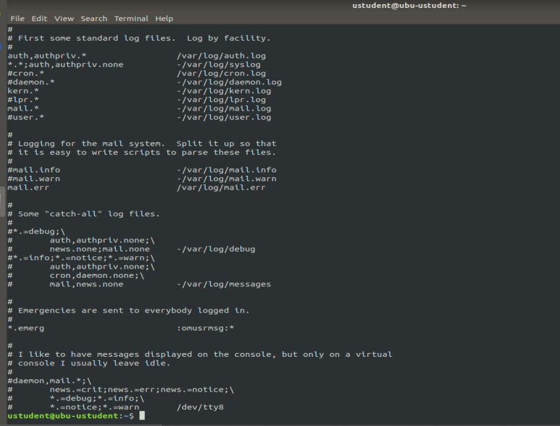

the machine is not currently configured to forward events to a centralized location In this case, you may need to configure the machine by editing the rsyslog.conf and rsyslog.d/*.conf files to set it up correctly for your SIEM.

IN Windows:

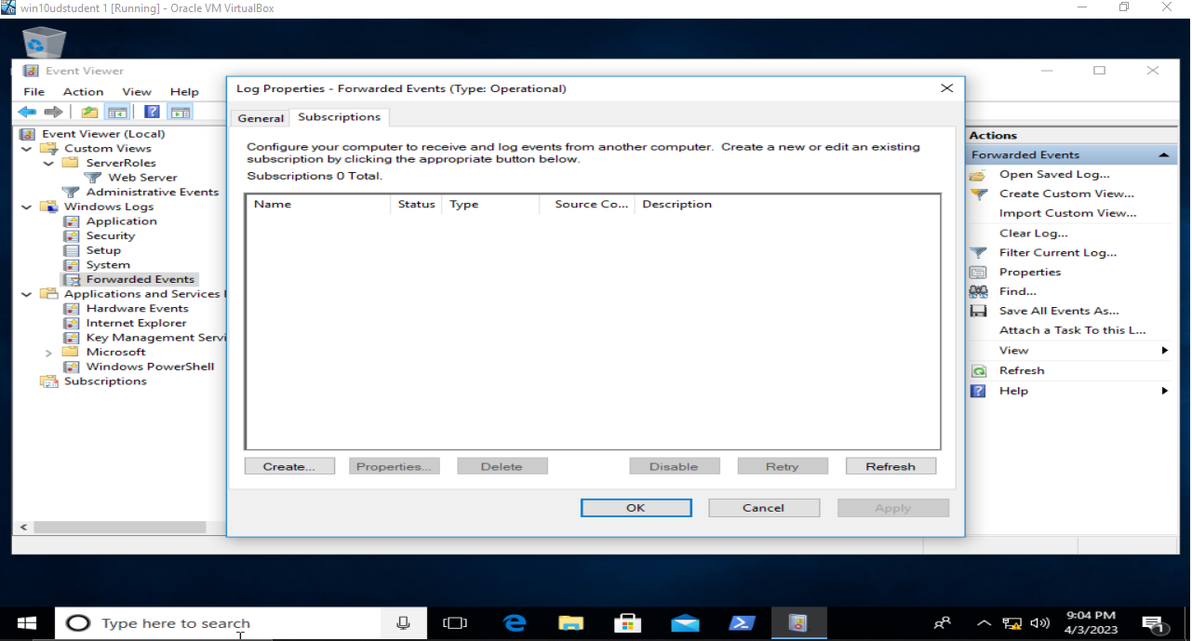

There’s no subscriptions.  
after checking the event viewer I found that, the machine is not currently configured to forward events to a centralized location using the Windows Event Forwarder. In this case, you may need to configure the machine to use the Windows Event Forwarder and set it up correctly for your SIEM.

Step 4: Assess Authentication Management at Targeted Assets

**Task 1**

Administrator and remote Desktop users which is “guest” user can remotely access windows machine.

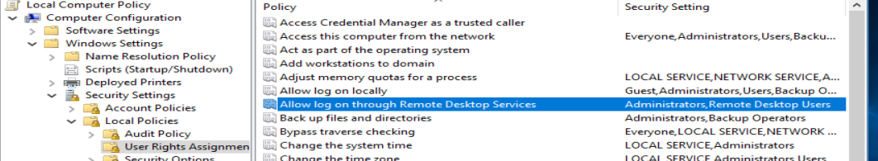

Root access permitted at Linux host

The users with executive permissions on Linux: ustudent 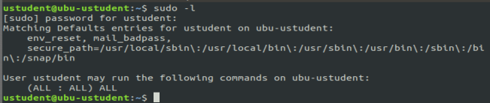

On windows there’s no users with executive permissions 

root remote login not allowed after checking /etc/ssh/sshd_config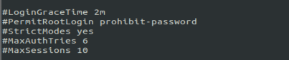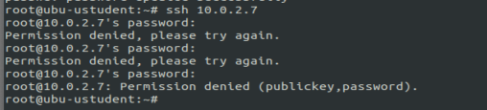

there is users that should not have remote access via ssh in Linux   
because ustudent has sudo privileges

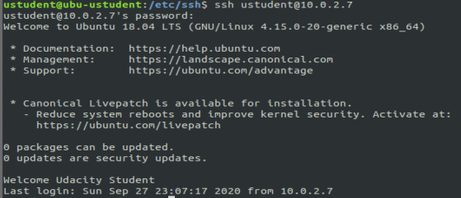

In Windows:   
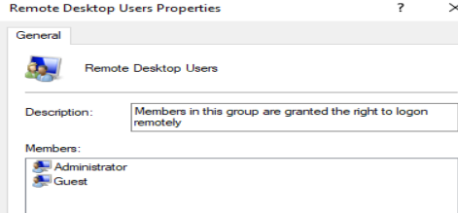  
there is other account that has been given remote desktop access

Summary:

* On the Windows machine, both the **Administrator** and **Remote Desktop Users** group, which includes the **Guest** user, have remote access to the machine. No users have excessive permissions.
* On the Ubuntu machine, the **ustudent** user has executive permissions and root access is permitted. However, remote login as root is not allowed. There are users that should not have remote access via ssh, including **ustudent** who has sudo privileges.

In order to improve the security of both machines, the following recommendations can be made:

* On the Windows machine, it is recommended to remove the Guest user from the Remote Desktop Users group to limit access to only administrators. Other non-administrative accounts should not be granted remote access.
* On the Ubuntu machine, it is recommended to disable root login entirely and ensure that only necessary users have ssh access. The ustudent account, which has sudo privileges, should not be granted remote access via ssh. Instead, a separate administrative account with limited permissions should be created for remote access.

### **Task 2**

audit the password policies in Ubuntu according to CIS Benchmarks 5.3.1

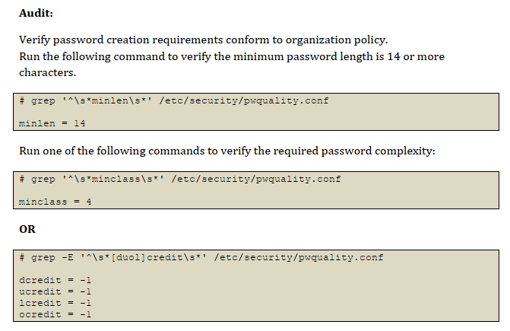

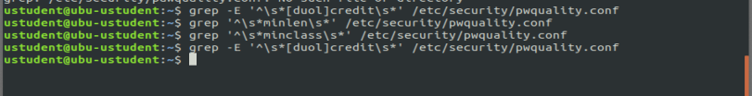

The commands don’t return any output which mean it’s not applicable After checking the system isn’t comply.

To remediate it 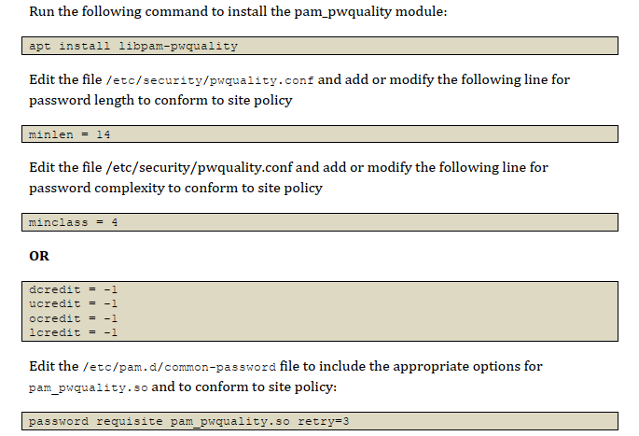

In Windows: we need to *Ensure 'Password must meet complexity requirements'*

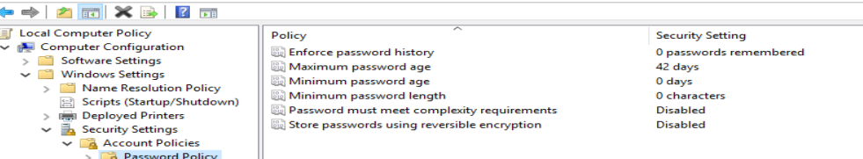

The current setting doesn’t comply with the windows 10 CIS benchmarks 1.1.5

Overview:

1. Password creation requirements: The password creation requirements should be set to ensure that passwords are strong and difficult to guess. This includes setting a minimum password length, requiring a combination of uppercase and lowercase letters, numbers, and special characters. The specific settings may vary depending on the organization's policy, but typically a minimum length of 8-12 characters is recommended.
2. Password complexity: The password complexity requirements should also be set to ensure that passwords are difficult to guess. This includes requiring a combination of uppercase and lowercase letters, numbers, and special characters. Additionally, common words, phrases, or patterns should be prohibited.
3. Failed login attempts: The number of failed login attempts allowed before sending back a failure should be set to a value that is in line with the organization's policy. Typically, a value of 5-10 failed attempts is recommended, depending on the organization's risk tolerance.

### **Task 3**

Windows Machine doesn’t comply with the (FIPS 140-2) policy

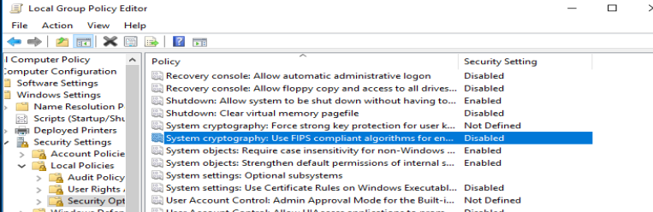

In Ubuntu

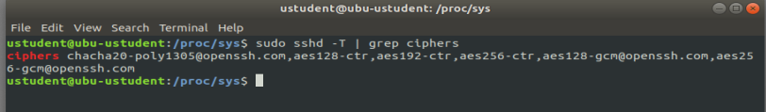

The systems aren’t compliant, we need to configure the system to use FIPS 140-2 compliant cryptographic algorithms and modules. This can typically be done through the system's security policy settings. For Windows, you can use the Local Security Policy editor or Group Policy Editor to configure the system to use FIPS-compliant cryptography.   
For Ubuntu, you can modify the system-wide OpenSSL configuration file located at /etc/ssl/openssl.cnf.

**Task 4**

On Ubuntu Machine:

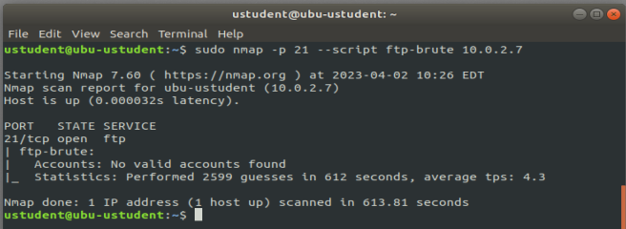

* The result of the ftp-brute script indicates that no valid accounts were found on the target FTP server after attempting 2599 guesses. This suggests that the FTP server has strong password protection and the default or common usernames and passwords have not been used.
* The security state of the FTP server seems to be in good condition as the script was unable to successfully authenticate any valid accounts.

On Window Machine:

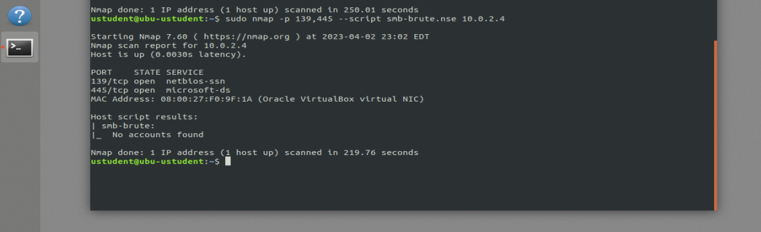

The results of the smb-brute script indicate that no accounts were found during the scan, which means that the script was not able to brute force or guess any valid login credentials for the SMB service on your Windows machine.

From a security perspective, this is a good result because it suggests that your SMB service is not vulnerable to brute force attacks.

The security state of these services can be improved. For example, you can secure the FTP server by enforcing secure authentication methods such as publickey and disabling the use of weak passwords. For the Windows SMB share, you can disable anonymous access and enable message signing to provide better protection against unauthorized access and tampering.

**Step 5: Final Report**

Windows 10 ENT

Ex

|  |  |  |  |  |
| --- | --- | --- | --- | --- |
| Host | High | Medium | Low | Log |
| 10.0.2.4 | 3 | 3 | 1 | 1 |

**IP Address: 10.0.2.4**

|  |  |  |
| --- | --- | --- |
| Service | Port | Sensitive Level |
| discard | 9 TCP | High |
| SMB protocol | 445 TCP | High |
| echo | 7 TCP | Medium |
| SMB | 445 TCP | Medium |
| ICMP | general TCP | Low |
| HTTP HEADERS | TCP | Log |

Expected detail format for vulnerabilities found.

**High**

**1- CVE-1999-0636**

**Issue**

The remote host is running a 'discard' service.

This service is unused these days, so it is advised that you disable it.

**Impact**

This service typically sets up a listening socket

and will ignore all the data which it receives.

**Mitigation**

Under Windows systems, set the following registry key to 0:

HKLM\System\CurrentControlSet\Services\SimpTCP\Parameters\EnableTcpDiscard

Then launch cmd.exe and type:

net stop simptcp

net start simptcp

To restart the service.

**Reference**

Details: Check for discard Service

OID:1.3.6.1.4.1.25623.1.0.11367

Version used: 2020-10-01T11:33:30Z

**High**

**1- CVE-1999-0503**

**Issue**

A number of known default credentials are tried for the login via the SMB protocol.

**Impact**

It was possible to login with the following credentials via the SMB protocol to

,!the 'IPC$' share. <User>:<Password>

operator:1234

**Mitigation**

Enforce strong password policies: This involves requiring complex passwords that are difficult to guess and ensuring that users change their passwords regularly.

**Reference**

cve: CVE-1999-0503

cve: CVE-1999-0504

cve: CVE-1999-0505

cve: CVE-1999-0506

**High**

**1- CVE-2017-7494**

**Issue**

known as the SAMBA Remote Code Execution from Writable Share vulnerability

**Impact**

It allows a remote attacker to execute arbitrary code with root privileges by uploading a shared library to a writable share on a vulnerable system and then causing Samba to load and execute the library.

**Mitigation**

To remediate this vulnerability, it is recommended to update the Samba software to a patched version.

Reference

**Medium**

**1- CVE-1999-0635**

**Issue**

An echo Service is running at this Host via TCP and/or UDP.

**Impact**

The echo service is an Internet protocol de ned in RFC 862. It was originally proposed for testing

and measurement of round-trip times in IP networks. While still available on most UNIX-like

operating systems, testing and measurement is now performed with the Internet Control Message

**Mitigation**

Solution type: Mitigation

Disable the echo Service.

**Reference**

cve: CVE-1999-0635

**Medium**

**1- CVE-1999-0635**

**Issue**

It was possible to detect the usage of the deprecated TLSv1.0 and/or TLSv1.1 protocol on this

system.

**Impact**

An attacker might be able to use the known cryptographic aws to eavesdrop the connection

between clients and the service to get access to sensitive data transferred within the secured

connection.

**Mitigation**

It is recommended to disable the deprecated TLSv1.0 and/or TLSv1.1 protocols in favor of the

TLSv1.2+ protocols. Please see the references for more information.

**Reference**

cve: CVE-2015-0204

cve: CVE-2011-3389

Low

**1- CVE-1999-0524**

**Issue**

The impact of this vulnerability is that it can allow an attacker to bypass certain security checks and access files or resources that they would not otherwise be able to access.

**Impact**

The remote host responded to an ICMP timestamp request.

**Mitigation**

- Disable the support for ICMP timestamp on the remote host completely

- Protect the remote host by a firewall, and block ICMP packets passing through the firewall in either direction (either completely or only for untrusted networks).

**Reference**

cve: CVE-1999-0524

url: http://www.ietf.org/rfc/rfc0792.txt

cert-bund: CB-K15/1514

cert-bund: CB-K14/0632

dfn-cert: DFN-CERT-2014-0658

**Log**

**8- HTTP Security Headers Detection**

**Issue**

Known security headers are being checked on the host.

**Impact**

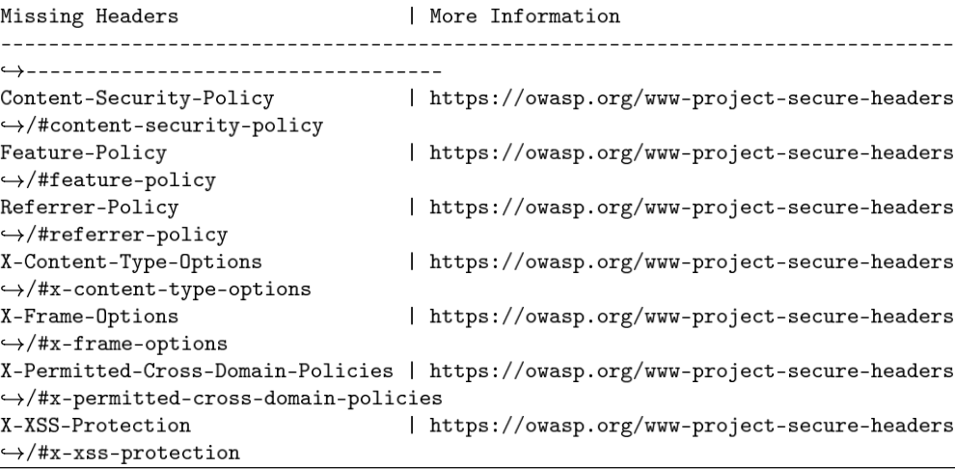

**References**

<https://owasp.org/www-project-secure-headers/>

<https://owasp.org/www-project-secure-headers/#div-headers>

<https://securityheaders.io>

Example of control checks & CIS benchmarks Windows 10 ENT

*18.9.102.2 (L1) Ensure 'Configure Automatic Updates' is set to 'Enabled'  
(Automated)*

**Result: not compliant, the policy is Disabled**



**Impact: Critical operating system updates and service packs will be installed as necessary.**

**CIS Controls:**Version 7  
3.4 Deploy Automated Operating System Patch Management Tools  
Deploy automated software update tools in order to ensure that the operating systems  
are running the most recent security updates provided by the software vendor.  
3.5 Deploy Automated Software Patch Management Tools  
Deploy automated software update tools in order to ensure that third-party software on  
all systems is running the most recent security updates provided by the software vendor.

*Ensure 'Enable Structured Exception Handling Overwrite  
Protection (SEHOP)'*

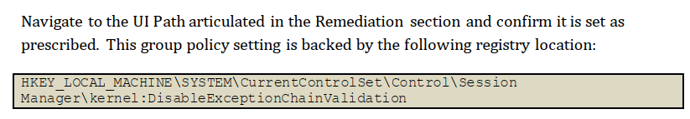

**Result**: not compliant, there’s no registry for it



**Impact**: After you enable SEHOP, existing versions of Cygwin, Skype, and Armadillo-protected  
applications may not work correctly.

**CIS Controls:**Version 7  
8.3 Enable Operating System Anti-Exploitation Features/ Deploy Anti-Exploit  
Technologies  
Enable anti-exploitation features such as Data Execution Prevention (DEP) or Address  
Space Layout Randomization (ASLR) that are available in an operating system or deploy  
appropriate toolkits that can be configured to apply protection to a broader set of  
applications and executables.  
9.3 Perform Regular Automated Port Scans  
Perform automated port scans on a regular basis against all systems and alert if  
unauthorized ports are detected on a system.

*Ensure 'Password must meet complexity requirements' is set  
to 'Enabled'*

**Result**: not compliant.



**Impact**: If the default password complexity configuration is retained, additional help desk calls for  
locked-out accounts could occur because users might not be accustomed to passwords that  
contain non-alphabetic characters. However, all users should be able to comply with the  
complexity requirement with minimal difficulty

**CIS Controls:**Version 7  
10.4 Ensure Protection of Backups  
Ensure that backups are properly protected via physical security or encryption when  
they are stored, as well as when they are moved across the network. This includes remote  
backups and cloud services.  
13.6 Encrypt the Hard Drive of All Mobile Devices.  
Utilize approved whole disk encryption software to encrypt the hard drive of all mobile  
devices.

Ubuntu 18.04

Ex

|  |  |  |  |  |
| --- | --- | --- | --- | --- |
| Host | High | Medium | Low | Log |
| 10.0.2.7 | 2 | 2 | 2 | 1 |

**IP Address: xxx.xxx.xxx.xxx**

|  |  |  |
| --- | --- | --- |
| Service | Port | Sensitive Level |
| NETBIOS-SSN SAMBA | 445 TCP | High |
| broadcast-avahi-dos | UDP | High |
| Anonymous FTP Login | 21 TCP | Medium |
| Telnet | 23 TCP | Medium |
| TCP timestamps | General/TCP | Low |
| ICMP timestamps | General/ICMP | Low |
|  |  |  |

Expected detail format for vulnerabilities found

**High**

**1- cve-2017-7494**

**Issue**

known as the SAMBA Remote Code Execution from Writable Share vulnerability, is a critical remote code execution vulnerability that affects the Samba file-sharing software

**Impact**

It allows a remote attacker to execute arbitrary code with root privileges by uploading a shared library to a writable share on a vulnerable system and then causing Samba to load and execute the library.

**Mitigation**

To remediate this vulnerability, it is recommended to update the Samba software to a patched version. The vulnerability was fixed in Samba versions 4.6.4, 4.5.10, and 4.4.14, so updating to one of these versions or a later version should resolve the issue

**High**

**1- Cve-2011-1002**

**Issue**

vulnerability is a buffer overflow vulnerability that affects the Avahi daemon,

**Impact**

It can be exploited by a remote attacker to send specially crafted packets to a vulnerable system, causing a denial of service (DoS)

**Mitigation**

To remediate this vulnerability, it is recommended to update the affected system with the latest security patches provided by the vendor.

**Reference**

NVD (National Vulnerability Database) entry: https://nvd.nist.gov/vuln/detail/CVE-2011-1002

Red Hat Security Advisory: https://access.redhat.com/security/cve/cve-2011-1002

Apache HTTP Server 2.2.18 release notes: https://www.apache.org/dist/httpd/Announcement2.2.html#2.2.18

**Medium**

**1- CVE-2017-1000030**

**Issue**

a remote attacker can bypass authentication and access sensitive data on an FTP server

**Impact**

Based on the files accessible via this anonymous FTP login and the permissions of this account

an attacker might be able to:

- gain access to sensitive files

- upload or delete files

**Mitigation**

you should disable anonymous logins.

**Reference**

NVD (National Vulnerability Database) entry: https://nvd.nist.gov/vuln/detail/CVE-2017-1000030

Red Hat Security Advisory: https://access.redhat.com/security/cve/cve-2017-1000030

Debian Security Advisory: <https://www.debian.org/security/2017/dsa-3889>

**Medium**

**1- CVE-2018-7640**

**Issue**

The remote host is running a Telnet service that allows cleartext logins over unencrypted connections

**Impact**

An attacker can uncover login names and passwords by sni-ng tra-c to the Telnet service.

**Mitigation**

Replace Telnet with a protocol like SSH which supports encrypted connections.

**Reference**

NVD (National Vulnerability Database) entry: https://nvd.nist.gov/vuln/detail/CVE-2018-7640

Red Hat Security Advisory: https://access.redhat.com/security/cve/cve-2018-7640

Debian Security Tracker: https://security-tracker.debian.org/tracker/CVE-2018-7640

Low

**1- CVE-2018-7750**

**Issue**

The remote host implements TCP timestamps and therefore allows to compute the uptime.

**Impact**

A side effect of this feature is that the uptime of the remote host can sometimes be computed

**Mitigation**

To disable TCP timestamps on linux add the line 'net.ipv4.tcp_timestamps = 0' to

/etc/sysctl.conf. Execute 'sysctl -p' to apply the settings at runtime.

To disable TCP timestamps on Windows execute 'netsh int tcp set global timestamps=disabled'

**Reference**

url: http://www.ietf.org/rfc/rfc1323.txt

url: http://www.ietf.org/rfc/rfc7323.txt

url: https://web.archive.org/web/20151213072445/http://www.microsoft.com/en-us/d

,download/details.aspx?id=9152

Low

**1- CVE-2018-7750**

**Issue**

The remote host responded to an ICMP timestamp request.

**Impact**

it allows an attacker to send specially crafted ICMP packets with malicious timestamp values to a target system. This can result in a denial-of-service (DoS) condition or remote code execution on the affected system

**Mitigation**

Various mitigations are possible:

- Disable the support for ICMP timestamp on the remote host completely

- Protect the remote host by a firewall, and block ICMP packets passing through the firewall in either direction (either completely or only for untrusted networks)

**Reference**

cve: CVE-1999-0524

url: http://www.ietf.org/rfc/rfc0792.txt

cert-bund: CB-K15/1514

cert-bund: CB-K14/0632

dfn-cert: DFN-CERT-2014-0658

Example of Log

Log

**3 - Telnet Unencrypted Cleartext Login**

**Issue**

The host is running a Telnet service that allows cleartext logins over unencrypted connections

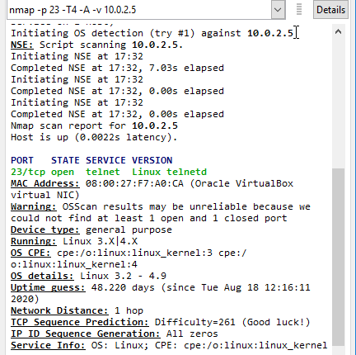

**Impact**

Attackers can uncover login names and passwords by sniffing traffic to the Telnet service.

**Mitigation**

Replace Telnet with remote access protocols that support encryption such as SSH.

**Reference**

<https://attack.mitre.org/techniques/T1021/>

Example of control checks & CIS benchmarks Ubuntu 18.04

*Ensure package manager repositories are configured*

**Result:** 

**Impact:** Systems need to have package manager repositories configured to ensure they receive the  
latest patches and updates

*Ensure XD/NX support is enabled*

**Result:** XD/NX support is enabled

**CIS Controls:**Version 7  
8.3 Enable Operating System Anti-Exploitation Features/ Deploy Anti-Exploit  
Technologies  
Enable anti-exploitation features such as Data Execution Prevention (DEP) or Address  
Space Layout Randomization (ASLR) that are available in an operating system or deploy  
appropriate toolkits that can be configured to apply protection to a broader set of  
applications and executables.

*Ensure address space layout randomization (ASLR) is enabled*

**Result:** address space layout randomization (ASLR) is enabled

**CIS Controls:**Version 7  
8.3 Enable Operating System Anti-Exploitation Features/ Deploy Anti-Exploit  
Technologies  
Enable anti-exploitation features such as Data Execution Prevention (DEP) or Address  
Space Layout Randomization (ASLR) that are available in an operating system or deploy  
appropriate toolkits that can be configured to apply protection to a broader set of  
applications and executables

*Ensure logging is configured*

**Result:** 

**Rationale:**A great deal of important security-related information is sent via rsyslog (e.g., successful  
and failed su attempts, failed login attempts, root login attempts, etc.).

**CIS Controls:**Version 7  
6.2 Activate audit logging  
Ensure that local logging has been enabled on all systems and networking devices.  
6.3 Enable Detailed Logging  
Enable system logging to include detailed information such as an event source, date,  
user, timestamp, source addresses, destination addresses, and other useful elements.

*Ensure password creation requirements are configured*

**Result:** not compliant

**Impact**:it can have a significant impact on the security of the system or platform that the password is protecting. Password requirements are put in place to ensure that passwords are strong, complex, and difficult for hackers to guess or crack.

**CIS Controls:**Version 7  
4.4 Use Unique Passwords  
Where multi-factor authentication is not supported (such as local administrator, root, or  
service accounts), accounts will use passwords that are unique to that system.

**Step 6: Final Assessment and Recommendations Based on Your Scans and Checks**

1. Vulnerabilities: Both machines have vulnerabilities that can be exploited by attackers, such as the NETBIOS-SSN samba vulnerability in Ubuntu and the SMB logon vulnerability in Windows. These vulnerabilities could be used to gain unauthorized access to the network and sensitive information.
2. Misconfigurations: There are several misconfigurations in both machines, such as the lack of software updates, incorrect permissions on PII folders, and anonymous access to shared folders. These misconfigurations could be used by attackers to gain unauthorized access and exfiltrate sensitive data.
3. Non-compliance: Both machines do not comply with certain policies, such as the FIPS 140-2 policy. Non-compliance could result in legal and financial liabilities for NuttyUtility in case of a security breach.
4. Lack of centralization: Both machines are not configured to forward events to a centralized location, making it difficult to monitor and detect security incidents in real-time.

Considering these risks, it is recommended that NuttyUtility implements the following measures before integrating these machines into its network:

1. Vulnerability scanning and patching: Both machines should undergo a thorough vulnerability scan to identify and remediate any vulnerabilities.
2. Configuration hardening: Both machines should be configured to comply with security policies, such as disabling unnecessary services, applying appropriate permissions on PII folders, and disabling anonymous access to shared folders.
3. Compliance auditing: Both machines should be audited for compliance with relevant security policies, such as FIPS 140-2.
4. Centralized logging: Both machines should be configured to forward events to a centralized location to enable real-time monitoring and detection of security incidents.
5. Privileged access management: NuttyUtility should implement a privileged access management (PAM) solution to control and monitor access to privileged accounts on both machines.

By implementing these measures, NuttyUtility can reduce the risk of security breaches and compliance violations associated with integrating these machines into its network.

In conclusion, while integrating these machines into NuttyUtility's network can provide some benefits, it also comes with significant risks that need to be addressed. It is recommended that NuttyUtility implements the measures outlined above before integrating these machines into its network to mitigate these risks. Ultimately, the decision to integrate these machines into the network should be made by the stakeholders based on a careful consideration of the risks and benefits.